**Task 1 – API**

1. Perform an API request to produce a list of all dog breeds

**Please see the below screenshot, performed API request to produce a list of all dog breeds**

**API -** [**https://dog.ceo/api/breeds/list/all**](https://dog.ceo/api/breeds/list/all) **[Used Postman Tool]**

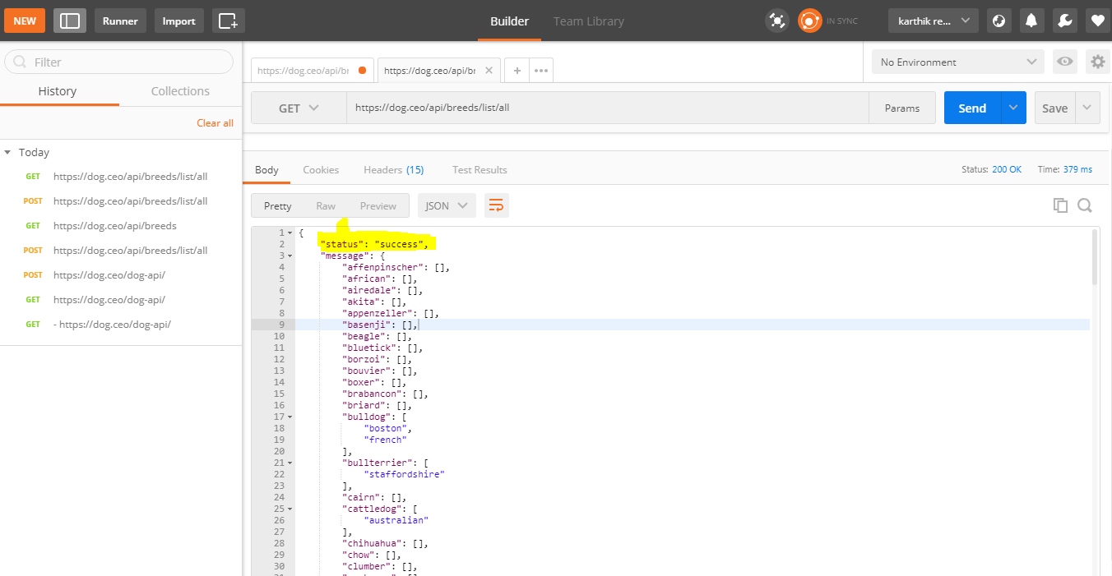

2. Using code, verify “retriever” breed is within the list

**Please see the below screenshot, “retriever” breed is present in the list of dog breeds. Status: Success-200 [Used Postman Tool]**

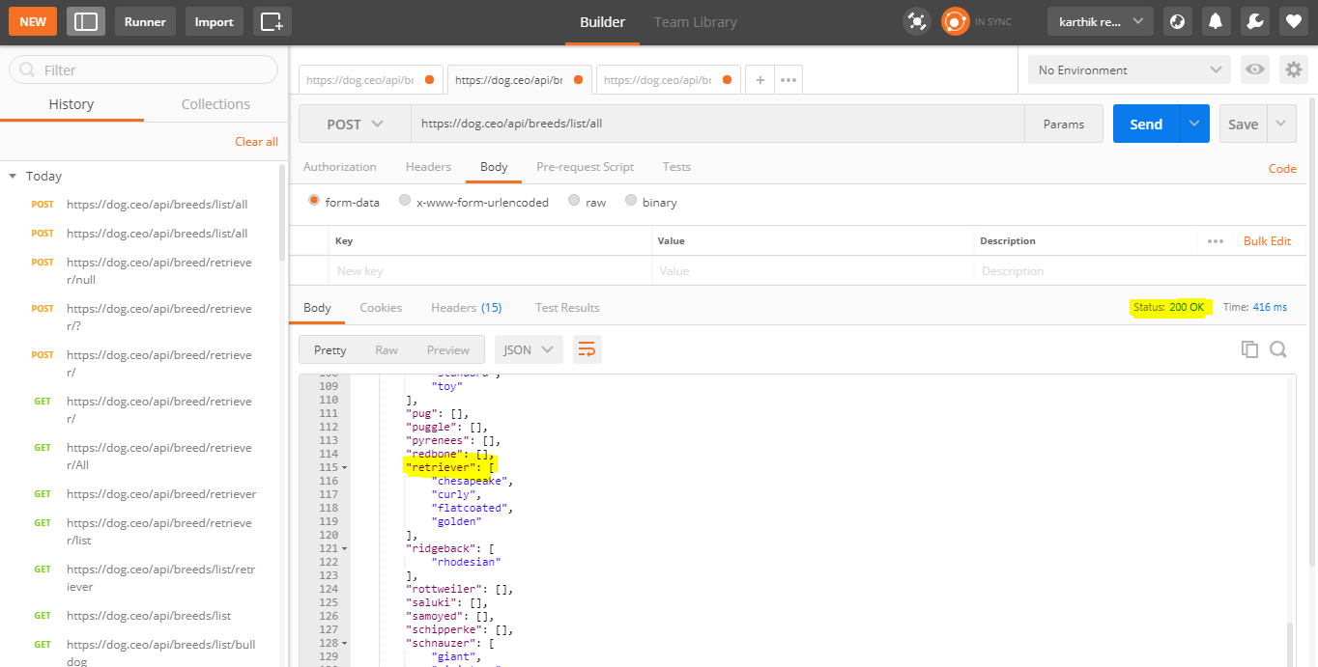

3. Perform an API request to produce a list of sub-breeds for “retriever”

**Please see the below screenshot, Performed API request to produce a list of sub-breeds for “retriever”**

**API -** [**https://dog.ceo/api/breed/retriever/list**](https://dog.ceo/api/breed/retriever/list) **[Used Postman Tool]**

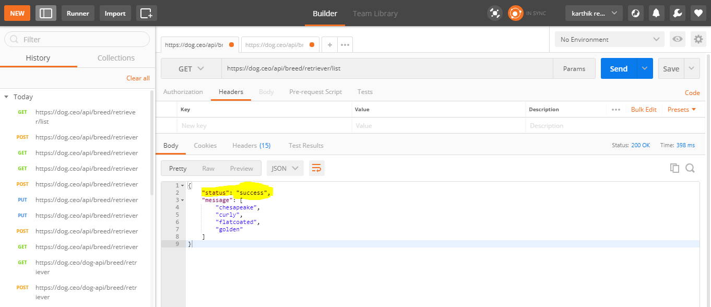

4. Perform an API request to produce a random image / link for the sub-breed “golden”

**Please see the below screenshot, Perform API request to produce a random image for the sub-breed “golden”**

**API -** [**https://dog.ceo/api/breed/retriever/golden/images/random**](https://dog.ceo/api/breed/retriever/golden/images/random) **[Used Postman Tool]**

